Most Mira Peace Centre Programme Development (Years 1-3)
Most Mira has been working in the Prijedor area for the last 8 years. We have worked with over 130 volunteers from 17 countries – including arts workshop leaders, architects, activists and academics. We have reached over 1500 young people and their families across the ethnic divide. They have told us they would like a permanent presence.
- Aims & Activities page 2
“A building is not just a building; it is a space where social change can happen”
We will create a welcoming Centre for all the community with multiple uses:
A Gathering place, a Creative space, a Learning space, a Skill Development and Work place
Planned activities include the following:
- Arts based work - Cultural Programme continuing the Most Mira drama, arts and music workshops and performances
- International Visits - International student / academic visits for peace building and human rights
- Peace Building Activities - making the connection between local and the international peace building efforts through learning residentials, local collaborative projects, and research.
- Social Enterprise – Developing a range of locally driven products with partner designers to sell to fund the ongoing costs of the centre.
- Running the Centre page 6

Full Time Staff: Centre Program Development Manager (2018)

Part Time Staff: Scaling to reach 4 officers by 2020 (Arts Program, Peacebuilding Program, Engagement & Communications, Social Enterprise)

Voluntary team: Advisory team, Youth Panel, Centre Forum
Running Costs, including staffing, building maintenance, activities:

Year 1 £40,500, Year 2 £46,500, Year 3 £52,500
- Funding the Centre page 8
The first three years of operation will require continued external funding as the income generating capacity of the centre will be in its infancy and by its nature hard to predict.
We estimate a continuing need for funding between £36,000 and £42,000 per annum in the first three years of the Centre’s operation.

- Sustainability Strategy page 11
The economic model for the Most Mira Youth Centre is similar to that of a Co-operative. It is intended for all income generated from the use of the building to go back into the running, maintenance and programme development costs. After three years we would expect maintenance costs and co-ordinator fees to be covered by the income generated from building hire and social enterprises, however there will always be a requirement for external funding to ensure the continued full operation of the Centre as it is planned.

5. Appendices pages 12,14,17
- Aims & Activities

A. Arts based work for next 3 years – TOTAL BUDGET £10,000 p.a.
Building on our knowledge of 3 years of arts festivals, 4 years of different art, music and drama projects rehearsing and touring in schools youth centres and theatres. Most Mira aims to develop this work alongside other centre activities such as peace building and social enterprise – giving young people more autonomy to develop their creative and cultural selves.

Theatre projects with young people

ARTS Children’s Theatre: Primary school students supported to organise their own productions and arts projects which are performed in the centre, toured to schools and to local theatres. Aged 12-16
ARTS Youth Theatre: High school students supported to organise their own productions and arts projects - cross art projects that involve drama, design, music and media which are performed in the centre, toured to schools and to local theatres. Aged 16-18
These would be 3 month long projects that include local youth, teachers and young professionals from different fields (architecture, art, peace building) and international art practitioners. Subjects are relevant to the current social issues.

Costs: £ 4,000 per annum per project

Site related performance

This performance includes local community, local and international artist (drama, fine art, poetry, music and architects). Re-imagining the site and building through art. Over a week participants will partake in the series of creative workshops that will lead to a final performance.
There is also a possibility to connect this with the peacebuilding project.
Variation can be also developed as residential proposals

Costs: £2,000 per annum

Art exhibitions

Photography exhibition. All inclusive project (possibility to involve youth from a special needs school). Advertise a call for the photos on the subject “Weekend” (or some other theme that is familiar to everyone, unites and offers possibilities). Open to everyone. The best 20 will be exhibited in the centre. Costs are printing of 20 large/medium photos.
Costs: £200 per annum

Knitting workshops – to cross over and develop into a social enterprise

Community project. Week long workshops. Participants: women from the local (divided) communities (workshop should be open to everyone) and international fine artist. Starting from the idea that knitting is a widely spread craft in the community, workshops will offering another inspiration (e.g. regarding design, fashion, use of colours and patterns…) This is opportunity for communities to mix and have a dialogue in non threatening environment as well as to learn about new ideas. Exhibit the products at the centre – possibly offering them for sale.
Costs: £1,000 (including material, travel costs, accommodation and artist fees) per annum

Media hub – to cross over with peace building activities

5 week course for young people interested in developing journalism, social media, marketing and graphic design skills. They report on the activities of the centre and use various communications to debate peace building and the arts creatively. They take briefs from the other projects being run and deliver these. Certificates and references provided. Eventually this group could take briefs from external organisations.

Costs: £2,800 per annum

TOTAL BUDGET FOR ARTS ACTIVITIES £10,000 per annum

B. International Visits for next 3 years SELF FUNDED
The youth centre will also be a hub for international researchers working on peace and reconciliation. We will host researchers who are conducting fieldwork in the area. We will collaborate on international research projects by contributing case studies and other data from the region. In addition, staff at the centre will maintain rigorous data and evaluations on all of our programmes in order to both improve and contribute to wider knowledge of local peace building initiatives. Currently there is a large gap in academic and policy literature between the work on international organizations on peace building and local grassroots initiatives. Our centre will work to document local peace building and contribute to larger scholarly debate on post-conflict reconciliation and peace building.
Costs: Self-financing via visitors – ZERO costs

C. Peace building Activities for next 3 years TOTAL BUDGET £2,500 p.a.
For the last three years, Most Mira has experimented and improved our Project on Peace building (jointly run with Humanity in Action- an international human rights network) that brings together local, national, and international activists to work on and discuss local peace building. Most Mira’s work on peace building has developed into a model that makes connections between the local and the international peace building efforts. We will do this in three ways: learning residentials, local collaborative projects, and research. We will encourage youth from the area to apply for national and international opportunities. This is important because most NGOs only have headquarters in Sarajevo or Mostar and so do not include perspectives or participants from rural areas, especially in the Republik Srpska.

The youth centre will hold three types of residential (18-25 year olds):
University residentials – fee-paying students stay for 5-7 days in the centre and village to learn about history of the war, memorialisation, reconciliation, arts activism. Students run at least one session for the Media Hub or Debate Club with local young people.
Campaigner residentials- young Bosnian and international activists work together for a week doing a similar program to the university groups. Each participant runs a workshop on their activism and the group works collaboratively on a joint project (travel costs covered for Bosnian participants).
Diaspora residentials Targeted at young Bosnian diaspora who often return to Bosnia for the summer holidays but do not know much detail about the politics or the history of the country. This is a chance to engage directly with young Bosnians with a critical reflection on what they have been taught from their families or learned from the media, in addition to connect them with local volunteer organisations. Funded through a need-based sliding scale.

Architecture for Democracy
Most Mira have used the participatory process of designing the centre to develop a peacebuilding programme called ‘Architecture for Democracy’, in partnership with lead architect PROJECT V Architecture. This has involved providing an informal educational and community engagement structure alongside the professional architectural and development process, giving UK and Bosnian architecture students and graduates the rare opportunity to be involved on a live architectural project in a real community, gaining on-site experience, exchanging knowledge with students from different institutions and developing new ideas and designs for social justice for end users in divided communities. Extending this to graphic design, set design, marketing and product design could be combined with the development of local social enterprise projects.

TOTAL BUDGET £2,500 per annum per project

This figure is understated as it takes into account that some of the peace building activities will be self financed and some will overlap with the other 3 key activities.

D. Social Enterprise Investment - TOTAL BUDGET £10,000 p.a.

(During construction and gradually developed after Centre completion)
The building project is a framework for the local community to showcase local skills and locally sourced materials, as far as possible to achieve a low carbon footprint, and to be innovative in designing for a collaborative future. During the participatory workshops and the design and construction process, ideas for developing local social enterprises will be developed with students, designers, experts and faculties from the fields of architecture, design and the arts.
This will involve research and developing local Most Mira branded products while working on 'Live Projects', including:
- wool based products such as contemporary ‘Priglavce’ woollen socks and clothing (developing the knitting workshops)
- insulation panels, furniture from locally sourced wood
- redeveloping local Earth Wall building technologies and ceramic tile industry with Lehm Ton Erde earth building specialists and sub-contractors
- prototyping and exhibiting marketable products through the set design and prop design aspect of the theatre project,
- establishing co-operative partnerships with local farmers and agricultural producers to grow, produce and market local food industry products from the rural area.
The aim of this area of Most Mira’s work is to develop locally produced products designed in partnership with international designers to market and small-scale export to help fund local Most Mira activities. The money generated will act as a key income source for the future sustainability of the centre.
This could be linked to the their promotion through quarterly 'markets' or 'sajem's' in the large open courtyard’
Products produced for Most Mira theatre project stage sets, props and costumes could be used as the test-bed for prototyping, exhibiting and selling some of the products at MM performances.
Some potential partners with experience in product development in BiH are being approached. The architectural project can be used as a vehicle for developing these ideas with local construction product manufacturers.

TOTAL BUDGET over 3 years £10,000 per annum

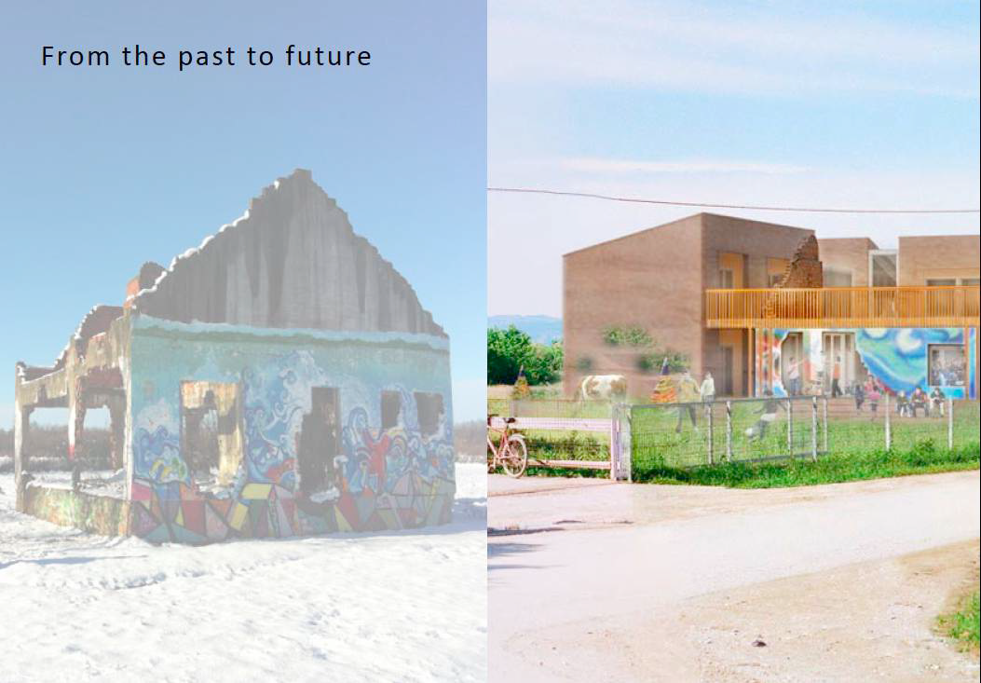

- Running the Centre

A. Staffing - Planned Centre roles

Year 1
Centre Program Development Manager: FULL TIME managing the work and development of the Centre. Can be an international candidate - will need to be onsite a lot of the time and a fluent Bosnian speaker.
- Responsible for Arts, Peace building and Social enterprise projects, managing the funding and finances of the Peace Centre, managing public relations of the Centre - communications and relationships with key stakeholders.
- Grant reporting and updating the Board of Trustees.
- Consulting with the youth panel and community forum.
- Facilities management: overseeing running and development of the building. Child protection: focal point.

Years 2&3
Engagement and Communications Officer: PART TIME (locally employed Bosnian) running the Youth Panel and Centre Forum, supporting these groups and developing their skills and knowledge so they can be advisors and ambassadors for the Centre, supporting the Centre Manager.
- Manages database of all centre participants, and mailing list of supporters.
- Manages Centre’s online presence and media content- co-ordinating the Program Officers.
Arts Program Officer: PART TIME (locally employed Bosnian) delivering the youth theatre and children’s theatre projects, arts projects, screenings and exhibitions in the building.
- Recruiting and managing the artist in residence.
- Liaising with the Peace building Program Officer and Social Enterprise Manager to ensure programs support each other’s work.
- Budget responsibility for area of programming, monitor and evaluate projects, liaise with youth panel and community forum. Managed by Centre Program Development Manager.
- Reports child protection and wellbeing concerns to Centre Manager. Responsible for media content for program area.
- Supported by arts volunteers - teachers, youth workers, young artists.
Peacebuilding Program Officer: PART TIME (locally employed Bosnian) delivering the alternating Media Hub and Debating Clubs for high school students, delivering the Youth Summer Peace building Camp and 2-3 university peace building residentials a year.
- Developing relationships with relevant academic institutions.
- Budget responsibility for area of programming, monitor and evaluate projects, liaise with youth panel and community forum.
- Managed by Centre Program Develop Manager. Reports child protection and wellbeing concerns to Centre Manager.
- Responsible for media content for program area.
Social Enterprise Manager: PART TIME (locally employed Bosnian) researching and developing a feasible and aspirational social enterprise for the Peace Centre which has a sound business plan.
- Ensuring profit is eventually made to support the running of the Centre, managing work force and running apprenticeships for young people over the summer.
- Budget responsibility for area of programming, monitoring and evaluating projects, liaise with youth panel and community forum.
- Managed by Centre Program Develop Manager.
- Reports child protection and wellbeing concerns to Centre Manager.

B. Staffing Costs
Project manager/ Co-ordinator for programme activities (full time) years 1-3
Salary: £12,000 (this includes salary, income tax, employer's tax, and pension contribution. Pension payments are obligatory by law. £5,000 travel budget for centre activities. Total £17,000 per annum

2 Part Time Staff – year 2
£3,000 pp totalling £6,000
4 Part Time staff – year 3
£3,000pp totalling £12,000

Total Staff Costs

Year 1 £17,000
Year 2 £23,000
Year 3 £29,000

C. Maintenance costs of building – electricity /rates etc

Total £1,000 per annum

D. Activities per annum

Arts Projects £10,000
Peace building activities: £2,500
Social Enterprise set up/Development stage: £10,000

TOTAL COSTS OF RUNNING THE CENTRE per annum:

Year 1 £40,500
Year 2 £46,500
Year 3 £52,500

- Funding the Centre

a) Initial funding strategy:

The first three years of operation will require continued external funding as the income generating capacity of the centre will be in its infancy and by its nature hard to predict. We estimate that the income generating capacity will be at around 40% of potential during the first year, rising to 70% in the second year and then at 100% by year 3, in 2020.

Inevitably the activities that are planned for the Centre will depend on the levels of funding that are generated as in the previous experience of Most Mira, so there is inherent flexibility built into the financing strategy for the running of the Centre.
 | 2018 | 2019 | 2020
Potential self generated income: | £4,240 | £7,420 | £10,600
Running Costs | £40,500 | £46,500 | £52,500
External Funding Requirement | £36,260 | £38,080 | £41,900

b) Income Generating Building Uses
It is intended for all income generated from the use of the building to go back into the running, maintenance and programme development costs. Any leftover income is to be reserved for social enterprise, community development and future Most Mira projects. Forming close relationships with the user community, arts organisations and residents, the centre will employ self-funding strategies such as offering the use of its facilities in exchange for skills and time to hand over a sense of ownership for the operation and maintenance of the building to the user community and residents.

1. Local Hall Venue hire for 50 seated people / 80 standing (equipped with basic AV system & moveable stage).
- £200 whole day / £100 half a day
- Space for Performances, cinema screenings, rehearsals, lectures, weddings etc.
- approximate potential income per year £2,000
2. Expected revenues from future MM event ticket sales.

Film screenings £1 performances/plays £2
Expected no. of events 50-60 events (film screenings once a week + other events)
Yearly income from event ticket sales – £3,000

3. Local Rental income from office or studio space hire

Office seats 3-4 people - £600 per year
Arts studio space seats 12-15 people. £2,000 per year
2 x social enterprise workshop spaces seats 3-4 people. £1,000 per year at the lower level of estimate, increasing with profitability from 2020 onwards

4. Revenue from accommodation
- Cost of 4 person dorm per night - £6
- Cost of single bedroom per night - £12
Provision of 3 x singles and 2 x 4 person dorms - are expected to be small with shared showers & toilets

Potential income per annum - £2,000

TOTAL £10,600 per annum

5. Social Enterprises income (projected figures to be added to the above total)

See description page 4 and sustainable operation section page11.

We are currently having advisory meetings with Aquus Consultancy, ClearlySo, Big Issue Invest, Big Society and Social Enterprise UK researching more definitive figures of expected income generation.
c) External Fundraising Plans
- Fundraising events (50%)
- Private event hosted by Tony Elliott- agreed in principle

Target 1 donation of £10,000 for 3 years
- Private event hosted by Brian Lapping- to be discussed

Target 1 donation of £10,000 for 3 years
- Bosnian Embassy Event – authors / poets associated with Bosnia

- UK trusts and foundations (30%)

General applications:
- Sainsbury Family Charitable Trusts (probably Woodward). Priority.
- Esmee Fairbairn Foundation. Follow up application. Gave us grant of £10,000 in 2011 towards festival costs. NB they don’t fund capital costs. Otherwise MM is a good fit: arts and young people, organisations at a pivotal point artistically or organisationally, art as an instrument for social change, community cohesion or participation. Question is whether they will fund activities in Bosnia, but it is not specifically ruled out in guidelines. Using contact with trustee William Seighart. Apply anytime. Decision takes 3 to 4 months. Priority.
- The Lennox and Wyfold Foundation. £5-10,000. UK based charities but charitable causes include overseas relief.

Drama projects:
- British Council. Arts Council England Professional Development Grant. Backstage Trust + Dominic Flynn Theatres Trust contact

Peace building activities:
- Swiss Peace and Erste Stiftung.
- US Institute of Peace/Ford/Rockefeller

Academic and Student visits and exchanges:

Establish link with a university human rights/post conflict reconciliation course. First approach to Dr Janine Clarke, Sheffield University (Bosnian speaker)
- International / European / US grants (20%)

- National Endowment for Democracy, existing funder, new grant application in April
- Balkan Cultural Fund (successor of Balkan Incentive Fund).
- Applying now for travel grants from Step Beyond.

- Corporate Foundations

- De la Rue Foundation. Small sums. Support underprivileged students, educational activities that promote international understanding. Not normally in areas where there are no De La Rue customers, but probably could apply for costs of volunteers, architects workshops.

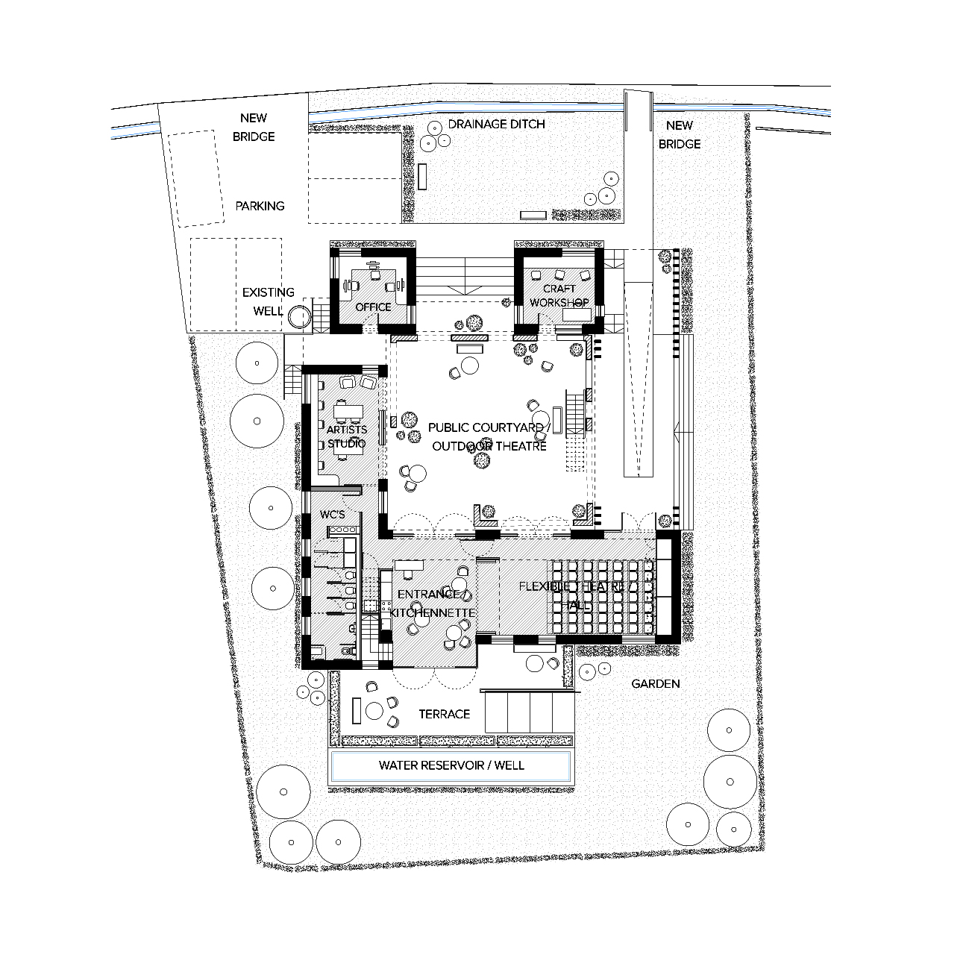
Planned Layout of Centre

- Sustainable operation of centre
As shown in section 3 the first three years of operation of the centre will require considerable external funding as the activities increase and more staff are employed. Beyond this horizon we would expect this funding gap to diminish as the social enterprises starts to generate more substantial revenues. We would anticipate that the centre will require continued external funding during its existence.
We can anticipate that the centre’s maintenance costs and co-ordinator fees beginning to be covered by income generated by 2020. Also the academic visits and student visits and exchanges will start to be income generating.

By 2020 the social enterprises should begin to be significant income generators. Most Mira aims to have recovered the costs of their first 3 years of expenditure on developing Social Enterprise projects through the sale and hire of Most Mira branded products by the end of Year 3 of building use. Increasing sale quantity etc.
Funding sources for social enterprise development to be researched: Templeton Foundation, World Bank EDIF Enterprise Innovation Fund, EU West Balkan Development and Enterprise Facility, Big Society Capital, Social Enterprise UK

Note on organisational issues
There are no paid staff in Most Mira London.

Consideration needs to be given to whether we need to next employ:

1. A Development Officer. At present all funding applications are researched and written by trustees.

2. A Creative Director for Marketing and Brand Identity (we are already in discussions with a UK and Bosnian graphic and web designers) to ensure delivery of an effective website, online forum, logos and promotional material etc. which all need to be in place before the building is finished.

Appendix 1

Example Quarterly activity plan

Quarter 1 Jan – March
- Youth Theatre (weekly 2 hour sessions)
- Children’s theatre (weekly 2 hour sessions)
- Media Hub (weekly 2 hour sessions)
- Planning for Easter and Summer residentials
- Youth Panel and Community Forum meeting

Quarter 2 April – June
- Youth Theatre (weekly 2 hour sessions)
- Children’s theatre (weekly 2 hour sessions)
- Debate club (weekly 2 hour sessions)
- Easter Peacebuilding residential: University groups (1 week)
- Planning for Summer residentials
- Youth Panel and Community Forum meeting

Quarter 3 July - Sept
- Youth Summer camp: Arts Activism (theatre, poetry, peacebuilding) (1 week)
- Summer Peacebuilding residential: University groups (2 1 week courses)
- Social Enterprise skills (weekly 2 hour sessions)
- Artist in residence (3 months)
- Youth Panel and Community Forum meeting

Quarter 4 October – Dec
- Youth Theatre (weekly 2 hour sessions)
- Children’s theatre (weekly 2 hour sessions)
- Debate club (weekly 2 hour sessions)
- Planning for Easter residentials
- Youth Panel and Community Forum meeting

Sample first Quarter 1 timetable: building use for rehearsal workshop spaces, office space used throughout.
 | Arts | Peacebuilding | Social Enterprise | Governance
Monday | CLOSED | CLOSED | Running the  enterprise | CLOSED
Tuesday | CLOSED |  | Running the  enterprise
Wednesday |  |  | Running the  enterprise
Thursday | Monthly planning  meetings for arts  facilitators & partners | Bi-weekly debate club  / Media hub | Running the  enterprise | Centre staff  meetings
Friday | Space for local  arts group events  or meetings | Space for local activist  group events  or meetings | Enterprise skill  share session | Youth panel  meeting (every  three weeks)
Saturday | Youth theatre  / performances | Space for local activist  group events or meetings | CLOSED | Community  Forum meeting
Sunday | Children’s theatre | CLOSED | CLOSED | CLOSED

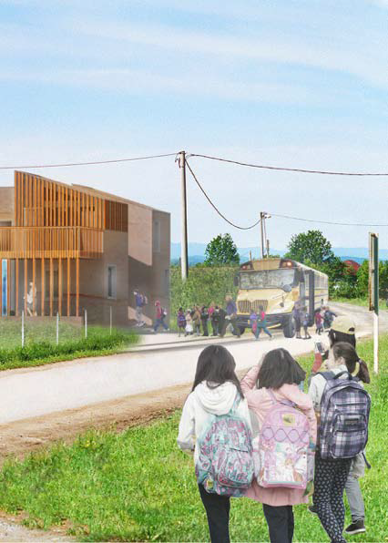

Appendix 2
Income Generating Building Uses – More Detail
An Area Schedule has been provided in the section, which shows current areas (m² and ft²) and potential occupancy levels for each internal and external space provided in the building and on the site. This will enable Most Mira to make approximate forecasts for income generation from arts based work, social enterprise and international visits. This includes income from renting desks, venue hire, ticket sales, hostel-like accommodation on 1st floor, renting out studio and workshop desk space.
It is however important to note that although some uses in the building are currently fixed / known and are an extension of Most Mira’s current programme, the participatory design and development process and consultations with user groups and residents is likely to lead to other ideas, some of which have been highlighted in the following text as opportunities. Most Mira do not aim to determine all of these uses without further consultation, to ensure a building that is responsive to the needs of the user community. Flexibility will need to be provided in the architectural design to enable other uses to develop over time.
Any potential figures for income generation area approximate and have been derived with local knowledge and comparison with local commercial and hostel rental / per day / per annum costs.
Building Areas:
Entrance Hall
A multifunctional open entrance lounge with a kitchenette. A bi-folding screen between the main performance hall and the entrance area is to allow this space to be used as a ‘back stage’ area during performances, while the two areas could be combined into one larger hall space to meet larger occupancy requirements on other occasions. The amenities for the entrance hall to develop into a small informal cafe, work lounge or occasional food hall are provided in the scheme, which could give further income potential to support Most Mira activities. The provision of wireless internet and media / computer equipment could lead to the development of an ‘Internet-Cafe’ environment.
Main Hall / Flexible Theatre
A large open hall space without a fixed stage adaptable for different functions, e.g. performance, rehearsals, concert, exhibitions, talks, panels, workshops. Other income generating activities could include venue hire for weddings, birthdays, festivals. The Main Hall is to be equipped with audio-visual equipment and wireless internet access. It can accommodate an audience of approximately 50 people (seated) and 80 people (standing), with the potential to extend into the Entrance Hall. The Main Hall can also extend into the Courtyard for Outdoor Theatre Events in the summer that could reach higher occupancy levels of over 100 people.

Artists Studio
A room with media equipment, which could either be shared by smaller groups of artists or individuals or rented out by a local arts organisation. This could lead to ‘Rent A Desk’ schemes. Two local organisations, who have previously collaborated with Most Mira on projects have expressed interest in using this space. This space could also be used as a small Media Centre or Micro Library, which could encourage yearly subscription or membership policies for users and residents, providing more certainty for yearly income from memberships. Other ideas to be discussed at future consultations are Internet-cafe, micro-print works etc
Lockable Office Space
Secure office separate from the more public areas of the building, which could be used as a meeting area / meeting table.
Workshop Spaces
2 Workshop spaces with hand held tools or small machinery are to be provided for a Social Enterprise project. Various potential partners, who are involved in rural product development in Bosnia and Herzegovina are being approached as potential partners. The ground floor workshop space could be used as a shop by local producers.
WC’s and Showers -
4 toilets (including 1 Accessible toilet) and 3 showers are to be provided giving adequate capacity for large groups of visitors during events and to support the accommodation element of the project.
Kitchenette -
The Kitchenette is part of the Entrance Hall. The design is based on a traditional small kitchenette ‘Cajna Kuhinja’, which has been integrated into the internal joinery and can be concealed within the wall with integral lockable sliding kitchen cupboards at times when the Entrance Hall is used for other purposes. The kitchenette could provide for the development of a small scale cafe. An oven with extractor hood is to be incorporated that would enable provision of food and refreshments for visitors and users. On occasions it may be possible to use the Main Hall as a dining room and open the centre for local food producers to use the facility to showcase local cuisines.
Accommodation / Bedrooms and Dormitories
Provision of accommodation on the first floor includes: 3no. single bedrooms and 2no. 4 person dorms, which are small with shared showers & toilets, but finished to a good standard. This is intended for volunteers, staff, students, arts residencies and other guests. There are various organisations who attract international visits in the Prijedor area and nearby. The accommodation element of the building could be used like a hostel during the busier seasons.

Parking and Minibus
A Parking space provides space for 5 cars, or 4 cars and a minibus. Most Mira intend to acquire a minibus to support local transportation requirements and make the site more accessible to local participants and school children, who may not be able to afford a transport. In future the Most Mira Minibus could also be rented out by visiting groups for their research and travelling requirements around BiH, which could lead to further income generation to support Most Mira activities.
Courtyard and Open Air Theatre
The existing ruined house is to be transformed into a public courtyard and open air theatre, which seats 100 people (150 standing). This space could provide the space for larger ticketed theatre performances and film screenings during the summer months. This space could also be temporarily covered with a tensile tent-like structure providing an area for monthly markets (sajem’s) for local producers to exhibit and trade their products. On a more regular basis it is seen as a work yard inside which stage sets could be build and tested for the theatre project, along with other art installations and social enterprise products.
Garden
The majority of the space around the building and ground floor terracing is to be used as a green landscaped garden with carefully selected planting and trees. Most Mira aim to plant fruit trees, which could provide a small scale yield for the production of Most Mira Jam’s and other similar products as a social enterprise. This social enterprise could be extended to a wider Co-Operative community project with local food producers and farmers in the surrounding rural landscape.
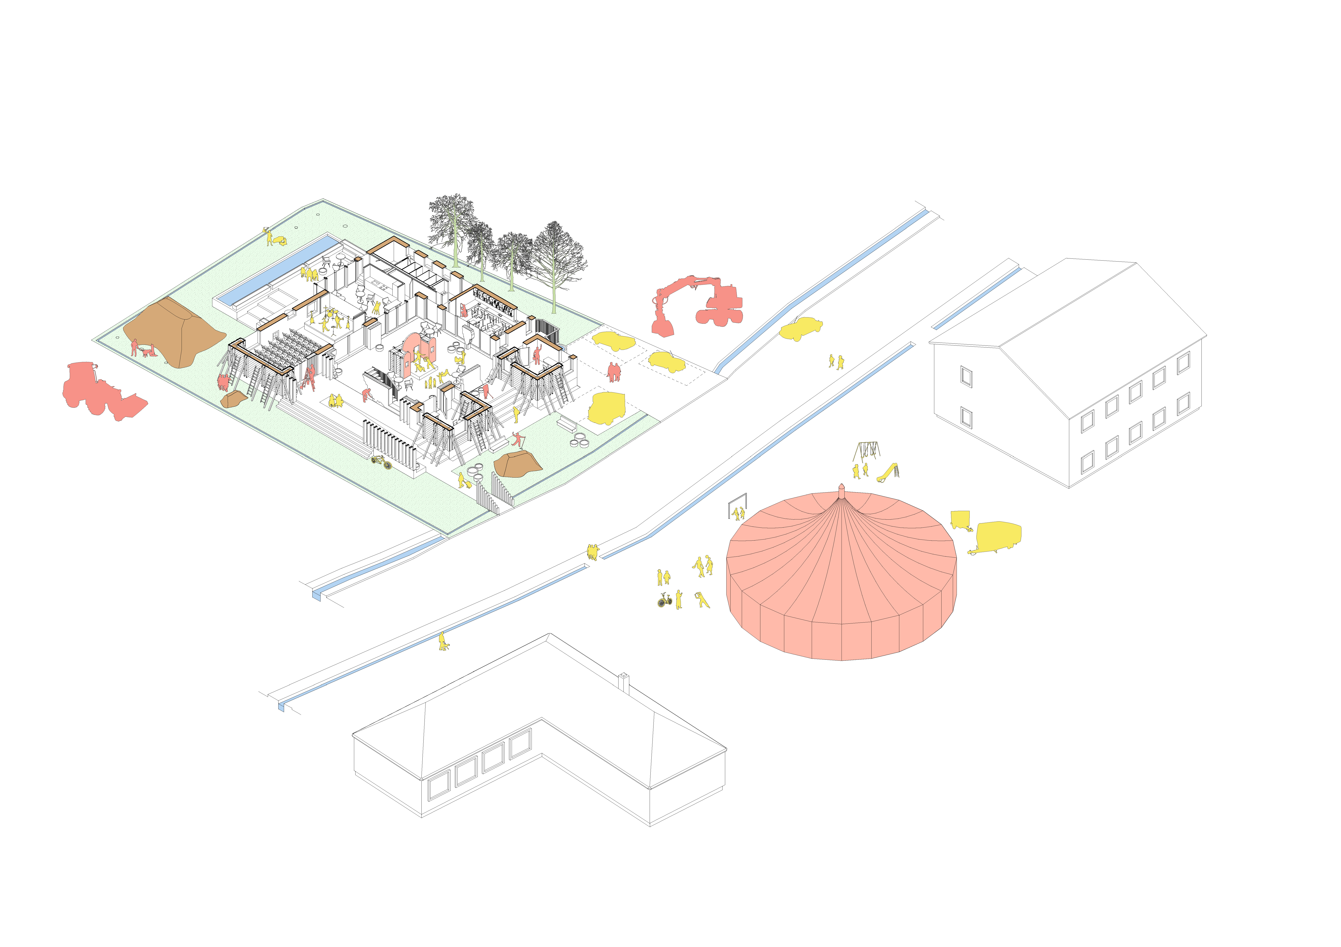
Appendix 3
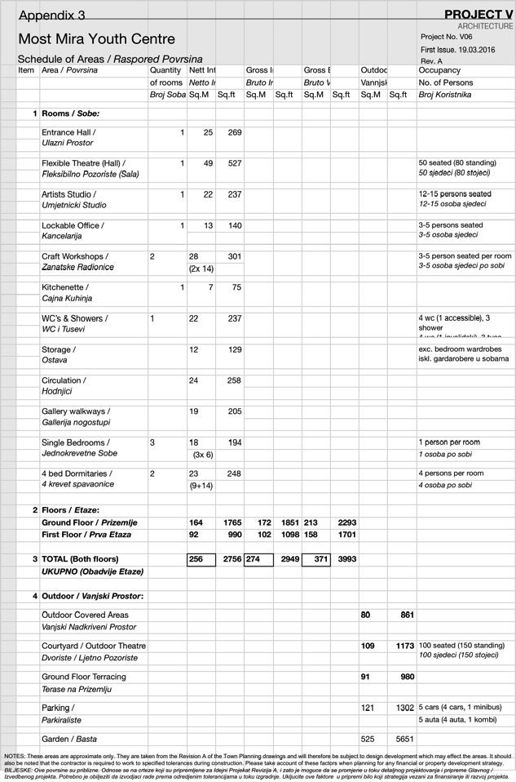Area Schedule

